**PUTTING TOYS AWAY** [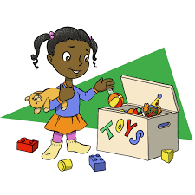](https://www.google.com/url?sa=i&url=https%3A%2F%2Fwww.focusonthefamily.com%2Fparenting%2Fage-appropriate-chores%2F&psig=AOvVaw097SkCHmtnP1yBpNnd4EzQ&ust=1588878964503000&source=images&cd=vfe&ved=0CAIQjRxqFwoTCNjdv6n6n-kCFQAAAAAdAAAAABAK)

This routine requires that toy storage is organized so that there is a designated basket/box or shelf location for each toy’s storage. These locations could be labeled with a photograph of the appropriate toy.

(When finished playing with toy/s)

1. Pick up a toy

2. Carry toy to toy-storage area

3. Put toy in designated basket/box or on designated shelf

4. Return to play area

5. Pick up another toy

6. Carry toy to toy-storage area

7. Put toy in designated basket/box or on designated shelf

8. Repeat steps until all toys are put away

(PIRS Team: Barbara Berger, Susan Monfet, Janice Torres, Simone Smith)